**Does organizational membership type affect**

**political participation and political satisfaction with the**

**political system in developing countries?**

Sydney Schauerhamer

Hawkins

POLI 370: Research Project: International Relations

Fall 2024

# Abstract

Using survey data from the World Values Survey this study evaluates how being a member of particular types of organizations makes an individual more or less likely to vote in local and national elections and what types of organizations are likely to incur more satisfaction with the political system when individuals are a part of them. Using data from Chile and Colombia in 2018 statistical models were created by running regressions. This study found that the type of organization people are a part of can significantly affect the frequency with which people vote at local and national levels. The study also found that the type of organization people were part of significantly affected individuals' satisfaction with their political system. The results of this study have several important implications for increasing voter turnout and give insight into the specific issues and sectors that the citizens living in the country care about.

# General Problem Area

Many countries working toward true democracy and public representation are drawn to increasing voter participation in their elections. Increased voter participation shows that the government is more democratic and more catered to the needs of the people. One source states “Democracy and participation have a mutually stimulating effect: democracy encourages citizens to participate and, in turn, by participating in democratic decision-making processes, citizens strengthen their democratic attitudes” (Quintelier & Van Deth, 2014). This means that by participating in a democracy citizens become better proponents of democracy. When the citizens are bigger proponents of democracy, they become more likely to support the country in its efforts to become more democratic. This idea becomes important when democracy is new to the country and the new governments and those supporting them want to ensure that the system will prosper. For these reasons, the appearance of being more democratic and the political strength that results from that has led some countries in the world to establish a system of voting in which people are forced to vote through legal precedent or coerced into voting for specific candidates through fear and intimidation. Consequently, in recent movements, there has been an emphasis on creating “free and fair elections.” Principles of Democracy states, "Free and fair elections allow people living in a representative democracy to determine the political makeup and future policy direction of their nation's government” (“Election and Democracy”)**.**

In addition, individuals crave connection and community where they can relate with people who share their experiences or hobbies. One article published by the Johns Hopkins University Press states that “individuals who are socially active with satisfying social relationships, for example, report above-average levels of happiness, lower levels of depression and anxiety, and higher resilience across a broad array of stressful life events and environment” (Seppala et al., 2013). Many people seek social connection by joining groups or organizations that promote and share their interests. Another study published in the Social and Personality Psychology Compass states that “we perceive ourselves and others, and we experience, understand, and act upon the world, through the lenses of the various groups we identify with” (Hogg et al., 2008).

Furthermore, there is evidence that people who are more satisfied with their government are more likely to vote. A study published in the Comparative European Politics journal states “analysis confirms that trust in parliament has a positive impact on turnout, and also satisfaction with democracy increases it” (Grönlund & Setälä, 2007). Therefore, governments trying to increase voter turnout in their nations may be inclined to examine different factors that can affect people’s perception of political satisfaction within the country. Members of different organizations may have varying levels of satisfaction with their government as the organizational ability to validate and promote specific ideas takes hold and can multiply throughout the organization.

This study examines the question: Does organizational membership type affect political participation and satisfaction with the political system in developing countries? This question originated from a curiosity about whether the number of organizations a person is a part of changes their likelihood of participating politically. Upon further research, information was found that indicated that the type of organization may be important in the understanding of political participation and satisfaction as some organizations may lead to people becoming less politically active or satisfied, and others or lead to greater participation and satisfaction. Thus, looking strictly at the number of organizations an individual was a part of would lead to the different effects from the various types of organizations cancelling each other out.

To understand the relationship between organizational membership type and political participation and satisfaction various statistical tests were created and evaluated. The independent variable in this study is the type of organization the individual is a part of the dependent variables are political participation and political satisfaction. Organizational membership type in this context is defined by whether someone reports themselves as a member of a particular type of organization with the different organizational divisions outlined by the World Value Survey. These divisions are outlined in the following ways: Church or religious organization, Sports or recreational organization, Art, music or educational organization, Labor Union, Political party, Environmental organization, Professional association, Humanitarian or charitable organization, Consumer organization, Self-help group or mutual aid group, and Women’s group. This definition of organizational membership limits the study only to be able to evaluate if the different types of organizations people are a part of have a significant effect on the dependent variable; it does not provide information as to how involved the individuals were in the organization or how many of that division of organization the individual was a part of.

Political participation is defined by local and national elections and if the individual self-described their participation in voting in those areas as Always, Usually, or Never. Other political participation indicators such as joining a boycott, donating to a group or campaign, and organizing political activities online are available in the World Value Survey data but were not used in this study for several reasons. None of the technology-driven activities, such as organizing activities online, were used as indicators because both Chile and Colombia are considered developing countries, and as such many survey respondents did not have internet or social media over which they could take these actions (Haerpfer et al., 2022). More involved actions of political participation such as joining boycotts or strikes were also not selected as indicators for this study as according to the US 2018 Human Rights Reports, in 2018, both of these countries had issues with widespread violence throughout the country (U.S. Department of State, 2018a and U.S. Department of State, 2018b). In 2018 in Colombia, there were a series of murders of activists throughout the country (Human Rights Watch, 2019). Due to the possibility of fear preventing people from taking these more involved actions, this study chose to use participation in local and national elections as the measure of political participation.

Finally, the second dependent variable of political satisfaction is determined on a 1-10 scale of how individuals responded to the question, “How satisfied are you with how the political system is functioning in your country these days?” (Haerpfer et al., 2022).

Given the nature of this survey data, there might be some discrepancy or confusion about how participation in different organizations or participation in voting should be coded. Still, the data has the advantage of a large sample size: about 974 observations in Chile and 1465 observations in Colombia. These large sample sizes decrease the effect of individuals who may have needed clarification in the coding for their responses.

# Study Structure

To study the effect of organizational membership type on political participation and political satisfaction OLS regressions will be created to evaluate how the independent variable and dependent variables relate to one another. An OLS regression assesses the percentage that the independent variable affects the dependent variable. This number can then be evaluated to determine how significant the impact is. This is useful because many different variables can affect any given outcome. This test is helpful because it can provide an idea of what variables contribute the most to the outcome and it allows researchers to add in controls that could also have an impact on the dependent variable which helps to mitigate the chances of a spurious correlation being perceived in the evaluation of the results.

Regression results provide the direction of the relationship between the two variables in the estimates column. The estimate column gives the estimated effect of the given independent variable on the dependent variable. For the voting regressions numbers in the estimate column, a positive number indicates a greater likelihood of participating in the election for the local and national election regressions, and a negative number indicates a decrease in the likelihood of voting in the given election. Similar patterns are present in the government satisfaction regressions. The P-value column shows how statistically significant the findings in the estimate column are. The P-value shows the likelihood of getting the values in the estimation column of organizational membership type on the likelihood of voting and government satisfaction if those variables did not affect the outcome. That is to say, a smaller P-value indicates that there is a greater impact from the independent variable on the dependent variable. For this study, the statistically significant figures were put in bold to differentiate them from the non-significant findings.

# Theory

As stated, “We perceive ourselves and others, and we experience, understand, and act upon the world, through the lenses of the various groups we identify with” (Hogg et al., 2008). The groups and organizations individuals interact with and have the ability to shape the way that people think and perceive the world. The study in the Social and Personality Psychology Compass continues stating, “Groups also provide consensual validation for our perceptions, feelings, attitudes, and behaviors” (Hogg et al., 2008). While groups in this study refer to the more general collections of any given number of people, the same principles of why people join groups can be applied to why people may be inclined to join different organizations.

Being part of community organizations allows a person to discuss more topics that are important to them and be validated and motivated by their peers in the organization. This validation and motivation can encourage an individual to take political action to bring attention to or change those topics they care about. Another study, published in Political Research Quarterly, evaluated how an individual’s network affected political participation. This study found that informal social interaction with more politically involved people led to greater political involvement from the individual being studied (McClurg, 2003). Therefore, interacting socially in an organization where several members are politically involved will lead to a greater number of the other members getting involved politically.

Additional research published in the International Journal of Voluntary and Nonprofit Organizations performed a similar study using the data from the WVS to evaluate the effect of organizational membership on political participation in South Korea and found promising connections between the two variables (Jeong, 2013). In this study, individuals who were a part of artistic and charitable organizations were more likely to participate in politics and those who were part of professional organizations were less likely to participate (Jeong, 2013). Since South Korea is a developed country and Colombia and Chile are both considered developing countries there will likely be variation in what organizations have the most significant effect on political participation.

People involved in more organizations will also be more satisfied with their government because they will feel like they have more of a say in politics and interact with the government differently. One study in the Journal of Social Economics found that “Political participation displays a robust, statistically significant and positive impact on life satisfaction” (Pacheco & Lange, 2010). Therefore, if people have greater life satisfaction from participating politically, they may also be subject to greater political satisfaction from their participation. Thus, if it is found that organizational membership type affects political participation it may also affect the political satisfaction that an individual feels toward their government. This study hopes to find supportive conclusions concerning organizational membership type, political participation, and political satisfaction in developing countries in hopes of encouraging stronger communities for the development of more free and fairly elected governments in these countries worldwide.

# Hypothesis

From this theory, two hypotheses will be tested. The first hypothesis is if an individual is part of specific types of organizations, they will be more likely to participate politically. Aspects of the theory support this cited earlier in the paper. Secondly, suppose the individual is part of the types of organizations that demonstrate greater political participation. In that case, they will be more satisfied with how the political system is functioning within their country than other citizens who are part of different types of organizations. This hypothesis is built upon the idea that greater political participation leads to greater life satisfaction and the idea that if life satisfaction is greater political satisfaction may be as well.

# Data

To evaluate my hypotheses data will be gathered from the 2018 world values surveys from both Chile and Colombia. The World Values Survey (WVS) is a dataset in which the researcher asks a series of questions to sample populations of different countries worldwide. These questions focus on individual responses and aim to get an understanding of how people in various countries view particular issues and activities in their personal lives and with their country. In the administration of this survey, administrators were asked to “explain to the respondent that there are no right or wrong answers” and to not stray from the order or phrasing of the prompts to standardize the administration process and prevent any human error that was reasonable to prevent (Haerpfer et al., 2022). For this study, responses from the questionnaire's social capital, trust, and organizational membership section will be compared to responses from the political interest and political participation section and the political culture and political regimes section.

Chile and Colombia were selected as case study countries because the researchers from the WVS can only evaluate a few counties each year. As a result, there were restrictions on the countries eligible for analysis, as this study specifically targets developing nations and those in South America. Chile and Colombia were the last countries to participate in the World Values Survey in the same year, they are both classified as developing countries and within the South American region. While data from different regions and years could have been used to evaluate these questions, as a researcher, I chose these countries and this year because I wanted to look at headlines from news sources in the country to assist in the analysis of the findings. Since I can speak and read Spanish, I elected to evaluate countries in South America so I could look at sources from the country published in Spanish to assist in developing my analysis. Focusing on 2018 helped me maintain clarity as I analyzed the various explanations for how membership in certain types of organizations influenced the different dependent variables.

The data in the survey is coded in a numerical format meaning OLS regression models can be created to evaluate the data and determine how the independent variable of the organizational membership type affects the dependent variable or political participation and satisfaction.

The independent variable will be evaluated by individual responses to questions 94-105 of the WVS (Figure 1). In response to these questions, individuals ranked themselves as 2 being an active member of that type of organization, 1 an inactive member, or 0 meaning they are not part of that type of organization. Responses in this section were recoded to reflect 1 if they were a member of an organization in this category and 0 if they were not a member of the organization. This prevents the need for differentiation between what it means to be an active member versus an inactive member and simplifies the interpretation of the data. An example of the variation between being an active member and an inactive member could be as follows. One individual could list themselves as being an active member of an organization that meets once a month, and the individual attends the meeting each month. Another individual could be a part of an organization that meets each week, but this individual only attends one meeting a month. These individuals would code themselves differently even though they attend the same number of meetings each month. The recoding of this variable would suggest that both individuals were part of an organization without differentiating the extent to which they are involved.

The dependent variable of this study will be the responses to questions 221 and 222 (Figure 2) and question 252 (Figure 3) to examine the effects of organizational membership on the two hypotheses outlined earlier. Responses for individuals who were not allowed to vote were not included in this study as being a member of an organization or not would have no influence on their political participation as defined in this study. The remaining responses to questions 221 and 222 were also recoded, with 1 representing never voting and 3 representing always voting. This adjustment was made to simplify the interpretation of the regression analysis, ensuring that positive values indicate increases in political participation, unlike the previous coding where negative values would have been associated with such increases.

Similar studies such as that of Jeong mentioned earlier elect to use the responses from questions 209-212 (Figure 4) as the data for the dependent variable of political participation. While these responses are demonstrative of increased political participation, they are more drastic in the amount of effort and resources needed to carry out or the conviction the individual must have to take action in that way. As Chile and Colombia were considered to have free and fair elections in 2018, as outlined in the country Human Rights Reports published by the US Department of State, this study will evaluate if people participated by voting in local and federal elections (U.S. Department of State, 2018, Chile and U.S. Department of State, 2018, Colombia).

Due to the variety and quantity of questions in the WVS, this study will operate under the assumption that the participant's responses were not affected by the Hawthorne effect in which the participants know they are being studied and thus respond differently than they would have otherwise (Sedgwick & Greenwood, 2015). In addition to this, OLS regressions allow for the addition of different controls to ensure that the values found are the results of the independent variable on the dependent variable and not the effect of another variable that is not being evaluated as part of the study. This study accounted for 6 different control variables. These variables were gender, age, educational level, and if the individual worked for the government, the private sector, or a nonprofit. These controls account for most other qualities that could affect political participation. For most studies that use data from humans, there is significant variation in the results of the dependent variable caused by social and traditional variation between men and women and the old and young. Education level is also a control in this study because more educated people are generally more likely to vote (Hartig et al., 2023). This control also helps to control for income as more educated people tend to have more income in developing countries (World Bank Group, 2024). Finally, this study controlled for the type of organization that the individuals worked for because those who work for the government and nonprofits, which are dependent on government funds and policies, are most likely to vote in an upcoming election regardless of the number of organizations they are a part of. They have different motivations outside of those created and reinforced by organizational mindsets that influence their decisions to vote in the elections. By controlling for these jobs, the study can get a better understanding of how organizational membership type affects this participation without the influence of the motivations created by the individuals’ jobs.

Reverse causality is unlikely in this study because it is improbable that voting would make an individual more likely to join an organization. However, concerning the topic being studied as outlined in the second hypothesis, being more satisfied with the government could lead an individual to join more organizations because the government provides more options for community engagement. One study, published in The Journal of Applied Sociology found that “with satisfaction increase (particularly in terms of political satisfaction), the participation of individuals will increase dramatically” (Saboktakinrizi et. al., 2016). In this study, political satisfaction was the independent variable, and political participation was the dependent variable. This finding is contrary to the theoretical reasoning that led to the creation of the second hypothesis stated in the paper. Despite this, the theoretical connection between the variables of organizational membership type and political satisfaction provides a logical connection that explains why organizational membership type affects political satisfaction. For this reason, the study will continue to evaluate the connection between these two variables with organizational membership type as the independent variable and political satisfaction as the dependent variable for the evaluation of the second hypothesis.

# Evaluation

The first regressions run for this study evaluated how the type of organization a person was a part of affected their likelihood of voting in local elections in Chile (Figure 5) and Colombia (Figure 6). In each country, the regression found that being a part of a political organization has a significant impact on increasing people’s likelihood to vote. This finding was surprising because when the national election regression was run the data showed that a member of a political organization was statistically significant in decreasing the likelihood of voting in national elections. This statistic is the same for Chile and Colombia. An explanation for this is that citizens place more trust in local governments than the national government. According to the Organization for Economic Co-operation and Development “Chileans place more trust in the police (52%) and local government (36%) than in national government, while political parties (14%) and the Congress (19%) are the least trusted institutions” (OECD, 2024). While no other organizational types had a statistically significant impact on voting in local elections in Chile, membership in religious and labor organizations in Colombia also had a statistically significant impact on the likelihood of voting in local elections with membership in religious organizations increasing the probability of voting and membership in labor organizations decreasing an individual's likelihood of voting. An explanation as to why religious organizations may be more inclined to vote is provided later in the paper. A reason why labor organizations may be less inclined to participate in local votes. The Center for Strategic and International Studies reports that “Colombia is one of the deadliest countries to be a worker or union member” (Abovyan et al., 2023). This organization goes on to report that “Threats against union workers in Colombia are the most common type of human rights violation in the country, making up 49.2% of violations regarding the right to life, freedom, and integrity” (Abovyan et al., 2023). Therefore, members of labor unions would be less inclined to vote because an individual admitting that they were a part of a labor union could lead to them being targeted by illegal armed groups.

An additional set of regressions was then run to evaluate the effect of organizational membership type on the likelihood of voting in national elections for Chile (Figure 7) and Colombia (Figure 8). Notably in both of these regressions membership in a political organization had a significant negative effect on the likelihood of voting in national elections. This is an interesting observation because while both countries are considered to be developing and to have had free and fair elections in 2018 there is a difference between how free the countries are.[1] In 2018 Freedom House scored Colombia at a freedom rating of 65 whereas Chile had a rating of 95 meaning Chile is more free than Colombia(Freedom House, 2018a and Freedom House, 2018b).

In Chile, in 2018 there was a series of feminist strikes and rallies advocating for an end to sexual violence, improved education about women in a school context, and the creation of institutions that are more responsive to the needs of women (Palacios-Valladares, 2022). One study published in the Canadian Journal of Latin American and Caribbean Studies evaluated how the existence of these feminist organizations and the collaboration and communication between them allowed for this movement to take shape within the country (Palacios-Valladares, 2022). This idea supports the hypotheses and theory outlined earlier in this paper.

The regression for Chilean national elections also shows that being part of environmental organizations has a statistically significant effect on the likelihood of voting in this type of election. In 2019 in Chile, a series of protests advocated for better social-environmental control protection from the government (Berasaluce et al., 2021). Social-environmental control is the idea that the government will work to protect the environment without causing undue harm to the economic, social, or health needs of the community in which the protections are being implemented (DEG Invest.). Though this protest occurred the year after the world survey was conducted in this area, one can believe that the ideas and issues surrounding the problem led to the demonstrations gaining popularity and attracting supporters for a significant time beforehand.

Finally, being a member of a self-help organization decreased individuals' likelihood of voting in national elections. An analysis of various news headlines and sources about Chile in 2018 revealed no reported events or cultural shifts that could explain why members of this type of organization were less likely to vote. One can speculate that an increase in belief in one’s strengths and capabilities could lead them to believe that there is no use for political participation because if the government can do it then the individual can do it for themself or with the help of others in their organization.

In Colombia, the only type of organization with a statistically significant effect on the likeness of voting in national elections in 2018 is membership in religious organizations. There were also no substantive headlines or sources that gave insight into why this type of organization might be more politically active at this time. One theory would be that according to the Freedom House evaluation of Colombia, the people in the country are “free to practice and express their religious faith or nonbelief in public and private” (Freedom House 2018b). While the country scored high in this area it did not score as highly in many other areas such as academic freedom, professional freedom, economic freedom, or political freedom. The statistically significant effect of members of religious organizations being more likely to vote could be produced because members of other organizations are afraid to vote out of fear of some consequence related to their political beliefs. Although the reasons presented in this section do not definitively explain why membership in these specific organizations led to greater political participation, they offer valuable insights into how organizations can reflect the issues and concerns important to a country's citizens.

Lastly, to evaluate the claims which were made in the second hypothesis, regressions were run which compared the level of satisfaction with the political system to the types of organizations people were a part of. In Chile (Figure 9) members of art and educational organizations were less satisfied with the political system at a statistically significant level compared to individuals that were members of other organizations. In the few years before 2018, the Chilean government instituted a process of education reform in which the system shifted from more market-focused education to more student-focused education (Ávalos & Bellei, 2019). While these reforms were likely beneficial to the educational system after some years it makes sense that those in educational organizations may not have been satisfied with the way the reforms had been progressing when they were first implemented. The regression results for Colombia (Figure 10) evaluating this idea found that members of religious organizations were more satisfied with the government than members of other organizations. The reasoning behind this satisfaction could be similar to that outlined earlier in this section. Specifically, because religious freedom is one of the most recognized freedoms in the country it can be more frequently practiced without fear of persecution or unwanted scrutiny. This differs perhaps from members of other organizations whose ideas and beliefs are not as well protected in the political system. Therefore, the people with less fear of the political system are more satisfied with the way that it is.

# Secondary Evidence for Organization’s Role in Political Participation

One of the studies cited earlier discussed how the structure of women’s organizations in Chile assisted in the ability of these groups to gain popularity and support for the protest movement which petitioned the government for specific concessions which would benefit the women of the country (Palacios-Valladares, 2022). In the article, the researcher states that “deep deliberative dialogues” within women’s organizations “helped introduce feminist ideas within the student movement, politicize some activists along feminist lines, and foster the buildup of student feminist mobilizing resources” (Palacios-Valladares, 2022).

Another study conducted by Jan Leighley from Texas A&M University in 1996 evaluated different reasons members of organizations may be more inclined to participate politically. She found that when members joined an organization, they were more likely to participate politically if they found that there was lobbying, normative incentives were more salient the individual was more likely to participate politically, and in organizations where social incentives were more salient, the individual was less likely to participate (Leighley, 1996). This means that if the individual felt that lobbying for a certain political policy would benefit the organization or that certain types of political participation would be held in high moral or ethical regard by the organization then the individual would be more likely to participate politically. If the individual felt that their political participation would negatively affect their social standing within the organization, they would be less likely to participate.

The final study discussed in this section was conducted by Daniel A. McFarland and Reuben J. Thomas and published in the American Sociological Review. This study examined how participation in different organizations as a child affected political participation in adulthood. They found that childhood participation in specific types of clubs and organizations such as the National Honor Society, drama club, vocational clubs, and religious organizations was more likely to participate in politics in adulthood (McFarland & Thomas, 2006). Each of these studies provides additional evidence and reasoning behind different factors and supports the idea that organizational membership type can affect the political participation of individuals.

# Implications and Conclusion

Increased political participation through increased turnout in local and national elections can have many different impacts on both democracy and the nation overall. One source states that “the outcomes of elections are quintessential public goods that all citizens enjoy (or not) regardless of whether they cast a ballot” (Franklin, 2004). This implies that the events and policies that result from the choices made during an election affect all of the citizenry of that local area or nation depending on the scope of that election. Thus, greater turnout is important to having results that better represent the ideology and desires of the people and their ideas of how they want to be governed. Increased voter participation is also important for strengthening government legitimacy in newer democracies like those in developing countries (Schraufnagel & Sgouraki, 2008).

The data found in this study suggests that the type of organization an individual is a member of is a significant indicator of their likelihood of voting for specific types of organizations. It also finds that these significant types of organizations are different from country to country. Supporting data found in news headlines from the time and specific countries indicated possible reasoning behind why the particular types of organizations may have had more significant effects on an individual's likelihood of participating politically. These findings along with additional secondary research that supported how organizations can affect political participation and political satisfaction align with the first hypotheses outlined at the beginning of this paper. This study found that the type of organization individuals were a part of could have either a positive or negative effect on the likelihood of participating politically depending on the different events and specific issues that were of particular importance to the types of organizations people were members of.

The second hypothesis was incorrect as it predicted that people who were part of types of organizations that were more likely to vote would be more likely to have higher satisfaction with the political system in their country. As the study shows, the types of organizations that were more likely to vote were different from the types of organizations in which participants were more politically satisfied with the government system in their country. Additionally, while there were a few types of organizational types that were statistically significant for the dependent variable of political satisfaction most organizational types were not statistically significant. From this finding additional research could be conducted on the alternate theory for the relationship between political satisfaction and political participation. This was the idea that increased satisfaction with the government led to greater political participation within the country. This concept implies that greater satisfaction leads to a greater sense of trust and the idea that “trust…has a positive impact on turnout” (Grönlund & Setälä, 2007).

This contrasts with the theory explored in this study, which investigated how trust in the government—shaped by different organizational types—could influence political turnout and, subsequently, political satisfaction. However, the theory was not explicitly stated, as the study only measured the likelihood of individuals voting in various types of elections, rather than their actual voter turnout. Nonetheless, similar causal reasoning can be inferred from the tests conducted and the reported evaluations. Since statistically significant insights were found in the study conducted in this paper additional research would need to be conducted to determine whether these findings were products of the types of organizations people were members of as studied and explained in this essay or products of the reflection of reverse causality as presented in this section. Despite this possibility, most of the statistically significant findings in this paper are supported by relevant headlines, events, and political freedoms that existed in the country around the time the data was recorded. These findings corroborate the data and support the theory as it was presented earlier in the paper.

Under the assumption that the findings of this study are true and accurate according to the theory outlined in this paper, there are a variety of implications that could be made regarding organizational membership type and political participation as defined by the likelihood of voting. This study would imply that developing countries that wish to increase their citizens' political participation by voting should encourage the citizenry to join organizations connected to the divisive issues and events that the citizens care about. Building upon this idea the government should promote participation in those organizations that encourage political participation over those which discourage it if they have the desire for greater turnout in their local and national elections.

Since relatively no statistically significant data was found that would connect an organization’s members’ likelihood of voting to their political satisfaction, governments that are trying to raise the political satisfaction of their citizens, should invest in research that tests different independent variables with the dependent variable of political satisfaction. The results found in this study however helped find an organizational type that was statistically less satisfied with the government in Chile in 2018. From this finding, one can infer that this structure of evaluation with organizational membership type and political satisfaction is useful for diagnosing the areas in politics that citizens may believe need government intervention in one way or another. Using the educational and art organizations as an example, the government could have seen that the citizens were unhappy with how the educational system was running using the data from the political satisfaction survey. In turn, they decided to implement educational reform policies to create better political satisfaction with the citizens who were outspoken in that sector.

The patterns that emerged from this study create intriguing opportunities for more in-depth research into the topics of organizational membership type, political participation, and political satisfaction. There are many fascinating insights that could arise from examining countries from different regions of the world and different times throughout history. Additionally, more research could be done evaluating the claims of the alternate theory which may have led to issues with reverse causality in this study. Each of the areas invites further research on this topic.

# 

# Appendix

Figure 1: World Value Survey Independent Variable Questions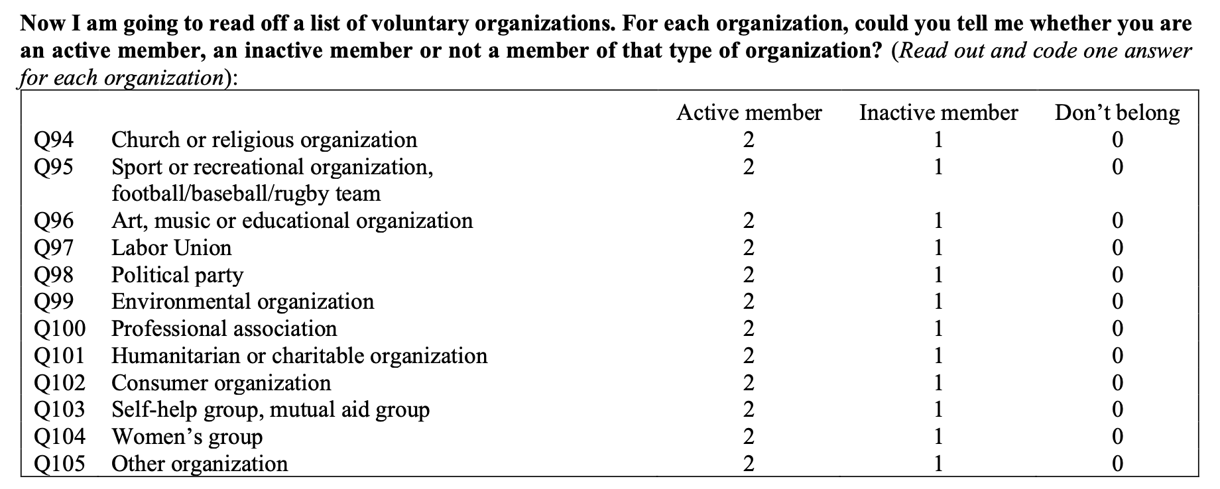

Figure 2: WVS Dependent Variable Questions for Participation Hypothesis

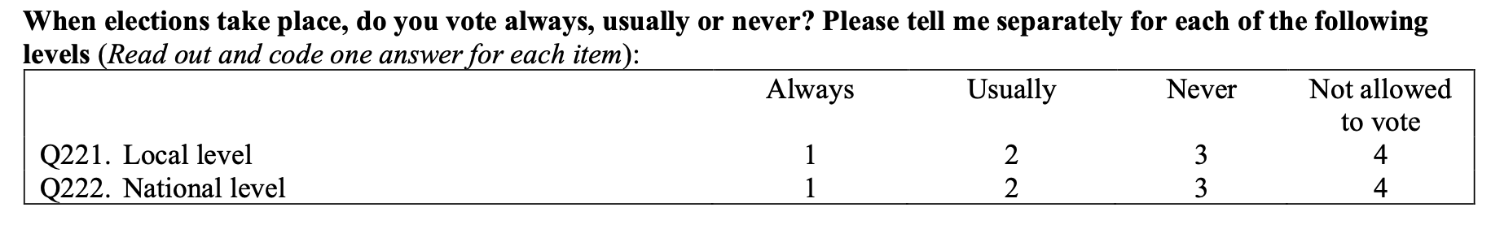

Figure 3: WVS Dependent Variable Question for Satisfaction Hypothesis

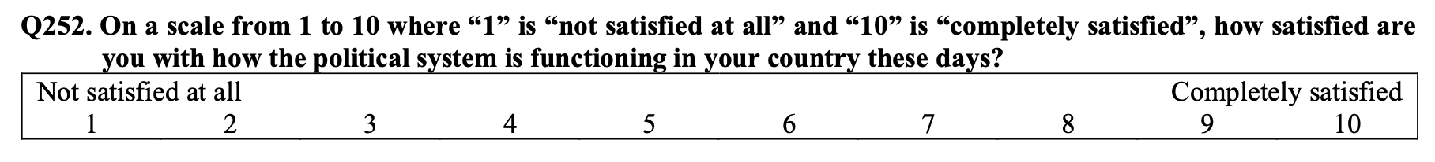

Figure 4: Alternate Studies Dependent Variable

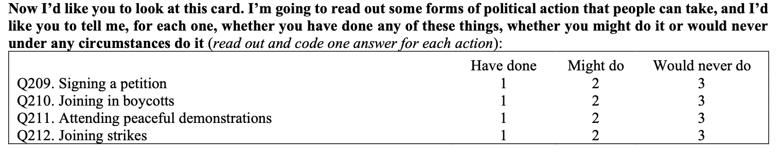

Figure 5: Chile Voting in Local Elections

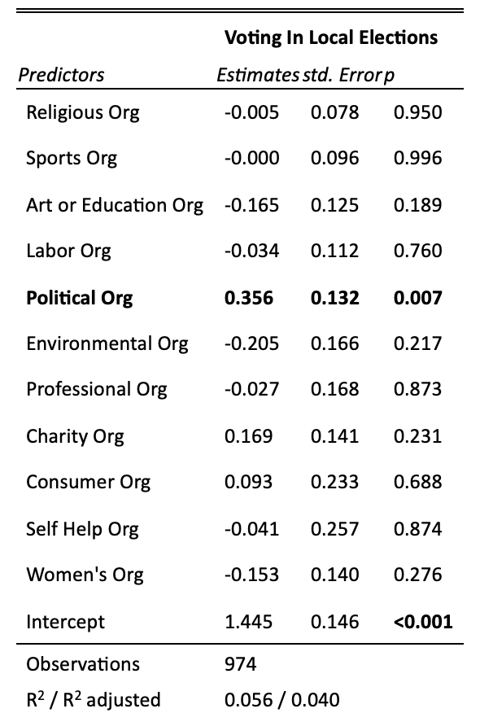

Figure 6: Colombia Voting Local Election

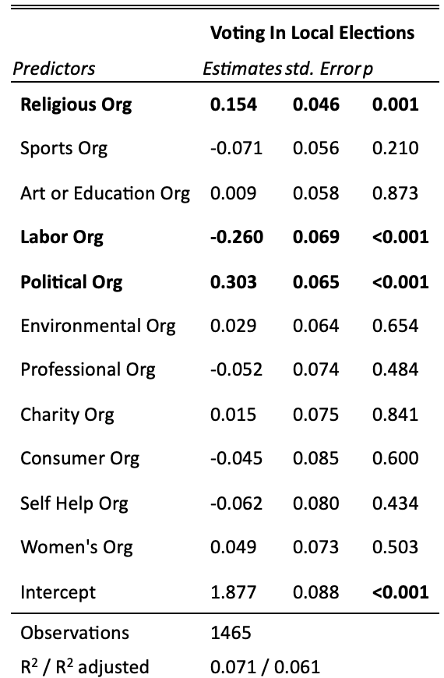

Figure 7: Chile Voting in a National Election

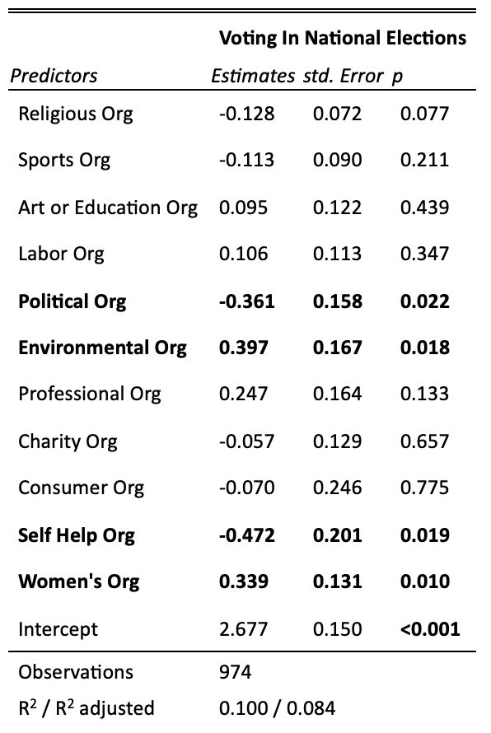

Figure 8: Colombia Voting in a National Election

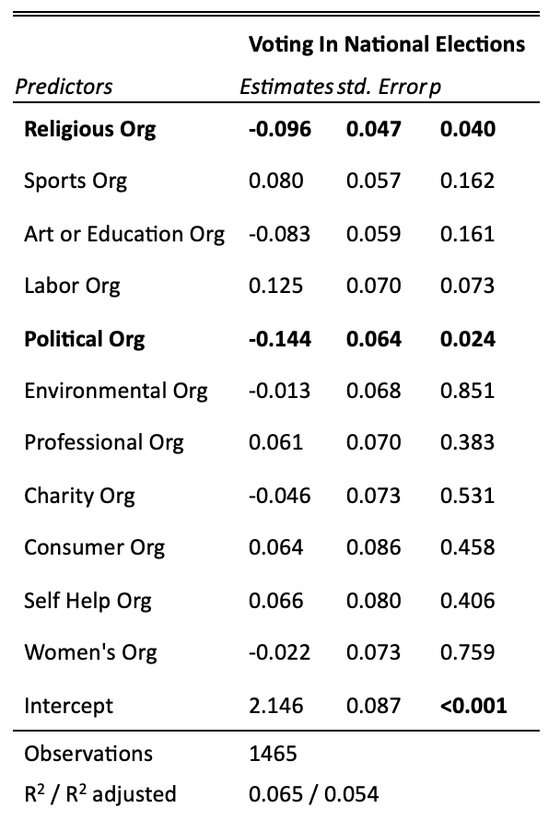

Figure 9: Chile Government Satisfaction

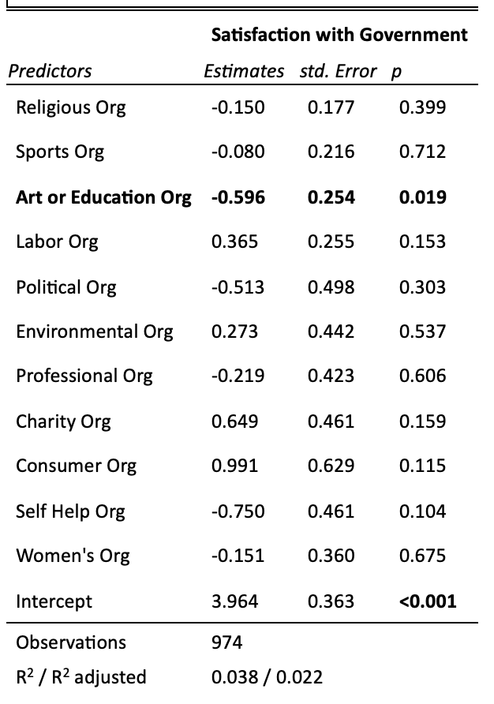

Figure 10: Colombia Government Satisfaction

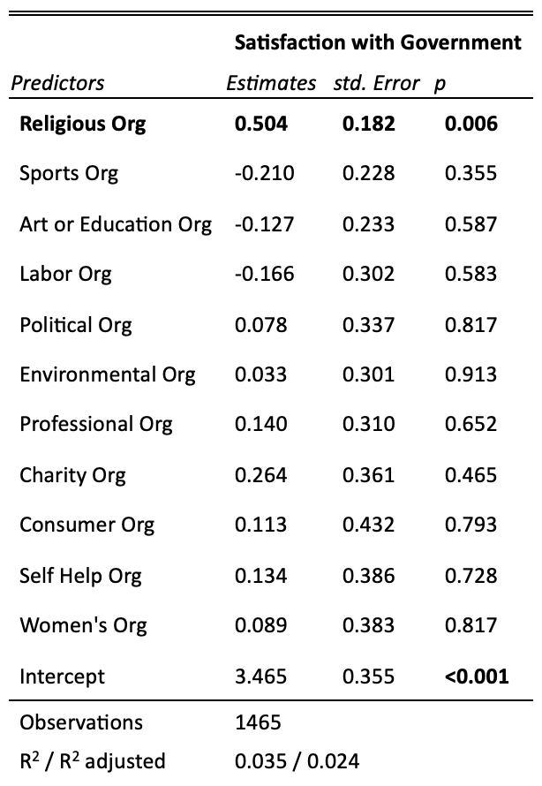

# References

Abovyan, K., Dietel, S., Hart, M., Heaney, B., Hoff, E., Hurley, A., Lee, A., Metzmeier, L., Murphy, E., Peck, H., & Quinn, M. R. (2023). *Shadows and bright spots: Colombia's developing democracy*. Center for Strategic and International Studies.

Ávalos, B., & Bellei, C. (2019). *Recent education reforms in Chile*. BRILL. Retrieved from<https://brill.com>

Ball, W. J. (2005). From community engagement to political engagement. *PS: Political Science & Politics, 38*(2), 287–291. https://doi.org/10.1017/S1049096505050620

Berasaluce, M., Palma-Behnke, R., Aldunce, P., & Jara, J. (2021). Social-environmental conflicts in Chile: Is there any potential for an ecological constitution? *Sustainability, 13*(22), 12701. https://doi.org/10.3390/su132212701

DEG Invest. (n.d.). DEG guideline for environmental and social sustainability. Retrieved November 19, 2024, from<https://www.deginvest.de/Impact-climate-focus/A-guide-to-our-standards/DEG-Guideline-for-environmental-and-social-sustainability/>

Election and democracy. (n.d.). *Principles of Democracy*. Retrieved October 25, 2024, from<http://www.principlesofdemocracy.org/election-dem>

Franklin, M. N. (2004). *Voter turnout and the dynamics of electoral competition in established democracies since 1945*. Cambridge University Press.

Freedom House. (2018). Freedom in the World 2018: Chile. Retrieved November 19, 2024, from<https://freedomhouse.org/country/chile/freedom-world/2018>

Freedom House. (2018). Freedom in the World 2018: Colombia. Retrieved November 19, 2024, from https://freedomhouse.org/country/colombia/freedom-world/2018

Grönlund, K., & Setälä, M. (2007). Political trust, satisfaction, and voter turnout. *Comparative European Politics, 5*(4), 400–422. https://doi.org/10.1057/palgrave.cep.6110113

Haerpfer, C., Inglehart, R., Moreno, A., Welzel, C., Kizilova, K., Diez-Medrano, J., ... & Puranen, B. (2022). *World Values Survey Wave 7 (2017-2022) Cross-National Data-Set* (Version 4.0.0). World Values Survey Association.<https://doi.org/10.14281/18241.18>

Hartig, H., Igielnik, R., & Perrin, A. (2023). 1. Voter turnout, 2018-2022. *Pew Research Center*. Retrieved November 18, 2024, from<https://www.pewresearch.org/politics/2023/07/12/voter-turnout-2018-2022/>

Hogg, M. A., Hohman, Z. P., & Rivera, J. E. (2008). Why do people join groups? Three motivational accounts from social psychology. *Social and Personality Psychology Compass, 2*(3), 1269–1280. https://doi.org/10.1111/j.1751-9004.2008.00099.x

Jeong, H. O. (2013). From civic participation to political participation. *VOLUNTAS: International Journal of Voluntary and Nonprofit Organizations, 24*, 1138–1158. https://doi.org/10.1007/s11266-012-9312-1

Leighley, J. (1996). Group membership and the mobilization of political participation. *The Journal of Politics, 58*(2), 447–463. https://doi.org/10.2307/2960236

McClurg, S. D. (2003). Social networks and political participation: The role of social interaction in explaining political participation. *Political Research Quarterly, 56*(4), 449–464. https://doi.org/10.1177/106591290305600407

McFarland, D. A., & Thomas, R. J. (2006). Bowling young: How youth voluntary associations influence adult political participation. *American Sociological Review, 71*(3), 401–425. <https://doi.org/10.1177/000312240607100303>

Ministerio Secretaría General de la Presidencia. (2022, diciembre 27). *Ley 21.524: Modifica la Carta Fundamental para restablecer el voto obligatorio en las elecciones populares*. Biblioteca del Congreso Nacional de Chile.<https://www.bcn.cl/leychile/navegar?idNorma=1187324>

OECD. (2024, November 15). *Drivers of trust in public institutions in Chile*. Retrieved from<https://www.oecd.org/en/publications/2024/11/drivers-of-trust-in-public-institutions-in-chile_ab22c269.html>

Pacheco, G., & Lange, T. (2010). Political participation and life satisfaction: A cross-European analysis. *International Journal of Social Economics, 37*(9), 686–702. https://doi.org/10.1108/03068291011062489

Palacios-Valladares, I. (2022). Deliberative talk, critical communities, and the making of the 2018 Chilean feminist student movement. *Canadian Journal of Latin American and Caribbean Studies, 47*(2), 195–218. https://doi.org/10.1080/08263663.2022.2077627

Quintelier, E., & Van Deth, J. W. (2014). Supporting democracy: Political participation and political attitudes. Exploring causality using panel data. *Political Studies, 62*(1_suppl), 153–171. https://doi.org/10.1111/1467-9248.12097

Saboktakinrizi, G., Rohandeh, M., Sobatiyan, S. M., & Jafari, A. (2016). Satisfaction and political-social participation (A survey). *The Journal of Applied Sociology, 27*(3), 97–116.

Schraufnagel, S., & Sgouraki, B. (2008). Voter turnout in Central and South America. *The Latin Americanist, 49*(1), 39–58. https://doi.org/10.1111/j.1557-203X.2008.00003.x

Sedgwick, P., & Greenwood, N. (2015). Understanding the Hawthorne Effect. *BMJ: British Medical Journal, 351*, h4672. https://doi.org/10.1136/bmj.h4672

Seppala, E., Simon-Thomas, E., Brown, S. L., Worline, M. C., Cameron, C. D., & Doty, J. R. (2013). Social connection and compassion: Important predictors of health and well-being. *Social Research, 80*(2), 411–430. https://doi.org/10.1353/sor.2013.0012

U.S. Department of State. (2018). 2018 country reports on human rights practices: Chile. Retrieved October 21, 2024, from<https://www.state.gov/reports/2018-country-reports-on-human-rights-practices/chile/>

U.S. Department of State. (2018). 2018 country reports on human rights practices: Colombia. Retrieved October 21, 2024, from<https://www.state.gov/reports/2018-country-reports-on-human-rights-practices/colombia>

Human Rights Watch. (2019). World Report 2019: Colombia. Retrieved November 18, 2024, from<https://www.hrw.org/world-report/2019/country-chapters/colombia>

World Bank Group. (2024). Education. Retrieved November 18, 2024, from<https://www.worldbank.org/en/topic/education/overview>

**LLM Disclosure**

I used ChatGPT to help me write some code to clean the data I was looking at to ensure that I would be able to use this data in the way I wanted to. I also used it to reword a couple of sentences to make them clearer than what I had originally written. I also used a site called Elicit AI to help find sources that fit with my research topic to support my claims and logic.

# Rubric

|  |  |  |  |
| --- | --- | --- | --- |
|  | High | Medium | Low |
| Ability to formulate an overall argument and assess it carefully based on evidence |  |  |  |
| Specific and clear evidence that is well-organized and provides insights into the hypotheses |  |  |  |
| Well-developed causal logic to support theoretical claims |  |  |  |
| Sophisticated and insightful theoretical ideas that engage the literature |  |  |  |
| Clear conceptual and operational definitions |  |  |  |
| Quality and specificity of the hypotheses |  |  |  |
| Research question that is non-normative, answerable/falsifiable, generates implications for understanding real-world problems, not too broad, not too narrow. |  |  |  |
| Grammar, Style, Formatting |  |  |  |

1. From 2012-2023 voting in Chile was a voluntary civic duty. Under the revised constitution published in 2024 voting in Chile is now compulsory according to Article 15 of the Constitution (Ministerio Secretaría General de la Presidencia, 2022)